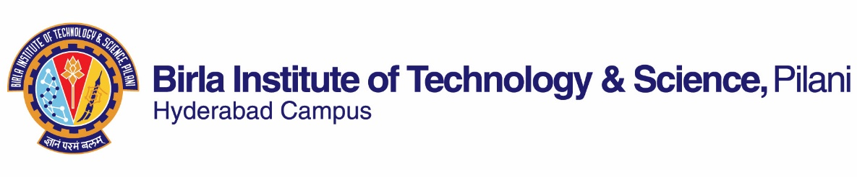

**Second Semester 2022 - 2023**

**Course Handout**

**Date: 16/01/2023**

In addition to Part I (General Handout for all courses appended to the Time Table) this portion further specific details regarding the course.

**Course No. : CHE F498 (3 0 3)**

**Course Title : Colloids and Interface Engineering**

**Instructor-in-charge : Jaideep Chatterjee**

**Instructors : Ramendra K Pal**

**Scope and Objective of the Course:**

This course deals with the engineering aspects of Colloids and fluid-fluid and fluid-solid interfaces. Its main focus to present fundamental knowledge of the above domains to the students. This course underlines that how this knowledge can be used to enhance the efficiency in many applications involving the above. In this context the course will also introduce the students to the fundamentals of surface active compounds and their applications. This course covers some frontiers of chemical engineering which can be applied to multiple industries.

**Course Pre/Co- requisite** (if any) **& Catalogue / Bulletin Description:** None

**Text book(s) [TB]**

1. P. C. Hiemenz, and R. Rajagopalan, Principle of colloid and surface chemistry, 3rd edition, Mercel Dekher, N.Y. 1997.
2. Drew Myers, Surfaces, Interfaces and Colloids, 3rd Edition, Wiley, 2006.
3. Pallab Ghosh, Colloid and Interface Science, 1st Edition, PHI Learning, 2009.

**Reference book(s) [RB]:**

1. Tharwat F. Tadros, Applied Surfactants Principles and Applications, Wiley-VCH Verlag GmbH & Co. KGaA, Weinheim, 2005.
2. M. J. Rosen, Surfactants and Interfacial Phenomena, Wiley-Interscience Publication, New York, 2004.

**Course Plan / Schedule:**

|  |  |  |  |
| --- | --- | --- | --- |
| **Lec. No.** | **Learning Objectives** | **Topics to be Covered** | **Chapter No** |
| 1-8 | Colloidal Systems | Colloidal stability. Kinetic theory of colloidal systems: sedimentation, centrifugation, diffusion, Intermolecular forces relevant to colloidal systems: Electrostatic and van der Waals forces. DLVO theory and its applications. | Chapter 2,11, 12, TB1 |
| 9-14 | Surface & Interface tension | Surface and interfacial tension, surface free energy, Surface active agents: Surfactants, Surface Pressure, surface excess and Gibbs equation, Micellisation. Theory of surface tension, contact angle, and wetting. Adsorption at fluid-fluid and fluid-solid interfaces | Chapter 6, 7  TB1  Chap 8 (T1) |
| 15-20 | Interface & Capillary Phenomena | Laplace equation, Kelvin equation, Young-Laplace equation, Capillary rise, kinetics of capillary rise, Wicking, Capillarity and porosimetry, liquid displacement from porous media | Chapter 6, 7  TB1 |
| 21-23 | Rheological Properties of Colloids | Rheological properties of emulsions and colloidal systems, Newtonian fluids, Shear Thinning, Shear thickening, Bingham Flow; Thixotropy; Measurement of Rheological properties. | TBA |
| 24-28 | Measurement Techniques | Measurement techniques of surface tension, Interface tension, contact angle, zeta potential, particle size distribution, Drop shape analysis | TBA |
| 29-30 | Industrial Applications | Overview of industrial applications of various colloidal & interfacial phenomena in the industries. | TBA |
| 31-33 | Emulsion, Microemulsion and foams | Preparation, mechanistic details of stabilization of emulsions; classification and stability of microemulsions; preparation and stability of foams | Chap 8 (T1), Chap 9 (T3) |
| 34-38 | Advanced Interfacial phenomena | Surface modification processes and Thin liquid films | Chap 7 & 8 (T3) |
| 39-40 | Lithography | Lithography & its applications | Class Notes |
| 40-42 | Industrial Applications | Overview of industrial applications of the above phenomena. | Class Notes |

**Evaluation scheme:**

|  |  |  |  |  |  |
| --- | --- | --- | --- | --- | --- |
| **EC No** | **Components** | **Duration** | **Weightage%** | **Date & Time** | **Venue** |
| 1 | Class Test 1 (OB) | 45 mins | 10 % | By 15/03 | **To be announced** |
| 2 | Mid-semester Exam (OB) | 90 mins | 25 % | 18/03 4.00 - 5.30PM |
| 3 | Class Test 2 (CB) | 45 mins | 10 % | By 15/04 |
| 4 | Assignment (OB)* | TBA | 10 % | By 30/04 |
| 5 | Comprehensive Exam (OB) | 3 Hours | 45 % | 20/05 AN |

**Chamber Consultation Hour:** Wednesdays (5:00 - 6:00 PM)

**Academic Honesty and Integrity Policy:**

Academic honesty and integrity are to be maintained by all the students throughout the semester and no type of academic dishonesty is acceptable.

**Notices:** All notices related to these courses will be displayed on the CMS system, with email to all registered students

**Make-up Policy:** Make-up for the Class tests may be granted only when one attends more than 80 % classes and valid justification and with prior permission from the Instructor-in-charge

**Jaideep Chatterjee**

**INSTRUCTOR-IN-CHARGE**

|  |
| --- |
|  |